AU-Plated Electrode Biosensors for Pathogen Detection and Genetic Diagnostics
Folding-based nucleic acid electrochemical biosensors offer an inexpensive and fast method for clinical measurements, pathogenic identification, and disease diagnostics. Previous research in our lab fabricated electrochemiluminescent (ECL) nucleic acid biosensors using commercial gold electrodes. This method allows for fast detection, but the gold surfaces require extensive cleaning before modification. To solve this, in situ chip based ECL biosensors can be fabricated with a fresh, easily modifiable gold layer deposited over carbon. The surface can be modified with an alkane thiol and a fluorescently tagged aptamer, allowing for biosensor specificity.
Gold deposition efficiency was characterized via surface roughness. Roughness values of 3.8-4.2 are considered ideal because gold deposition quality and quantity are fit for biosensing applications. Gold must cover the entire electrode surface, and nanostructures must preferentially form buds (spherical nanostructures) over dendrites (flora like nanostructures). Various chronoamperometry deposition potentials, step numbers, and pulse widths were tested to find optimal conditions for plating. The chronoamperometry method developed is shown in table 1. The surfaces of plated electrodes using this method were qualitatively assessed via SEM as shown in figure 1. Drop-casting techniques are currently being investigated to find optimal conditions for gold surface modification.
Table 1: Chronoamperometry Method for Gold Deposition
Parameter | Value
Initial Potential | -0.50 V
High Potential | 0.00 V
Low Potential | -0.50 V
Initial Step Polarity | Positive
Number of Steps | 6
Pulse Width | 10 s
Sample Interval | 1.0 s
Quiet Time | 2.0 s
Sensitivity | 1 e-003 A/V

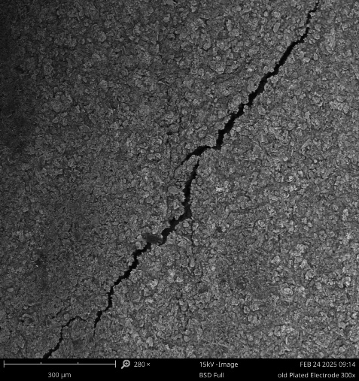  A | 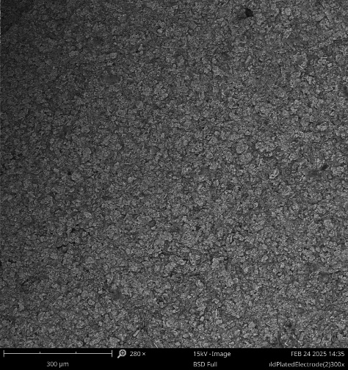  B
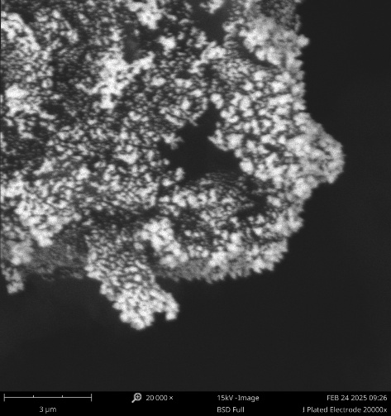  C | 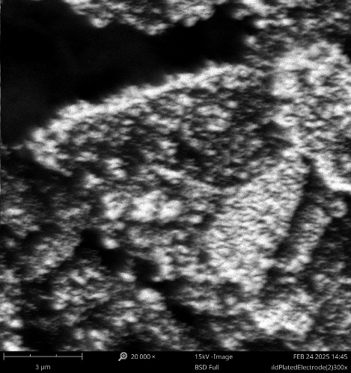  D

Figure 1: 280x & 20,000x Magnification Scanning Electron Microscope Images. Sub-figures (a) and (b) demonstrate uniform deposition of gold across electrode surface. Sub-figures (c) and (d) show buds as the dominant nanostructure formed.

