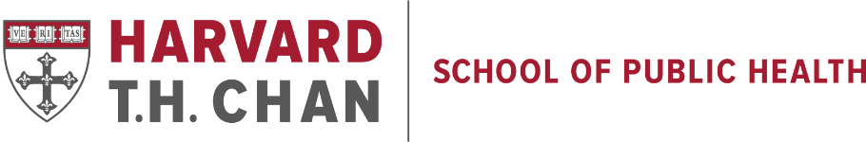

Job Board Title:
Postdoctoral Fellowship in Environmental Health
Location:
Boston (hybrid option)
Post Date
August 5, 2022
Expiration Date
October 4, 2022
Details:
Job Description
The Department of Environmental Health, Harvard TH Chan School of Public Health, is looking for an exceptional postdoctoral fellow to join their National Institute of Environmental Health Sciences (NIEHS) Center to work closely with the Center’s Community Engagement Core. The postdoctoral fellow will be working under the guidance of Dr. Gary Adamkiewicz and Ann Backus to develop and conduct studies that aid the CEC’s mission “to directly engage with communities and stakeholders to address the impacts of exposures to metals, organic chemicals, particulate matter, non-chemical stressors and other toxins on human health.” We aim to develop initiatives that can directly inform our collaborations with partners in the Boston area and set the stage for the next generation of applied urban environmental research.
Training Opportunities
The postdoctoral fellow will work with a dedicated mentor in a supportive research environment, with supplemental mentorship from a broader mentoring team within the NIEHS Center and the Department. Training in exposure assessment, epidemiologic methods, geographic information systems, data analysis, the tenets of community engagement, as well as experience writing for lay audiences, preparing manuscripts and writing grants will be available.
Qualifications:
Candidates must have a PhD or equivalent doctoral degree in environmental health, epidemiology or related field. Experience with community-based participatory research is a plus. More specifically, we seek an individual with a demonstrated commitment to projects of direct and practical relevance to communities. Relevant experience may include studies of environmental health disparities, research translation, policy analysis, community-based exposure assessment, or other related domains. Excellent writing and communication skills are required.
Comments:
To Apply:
The start date is flexible within the remaining months of 2022. The individual chosen for this position, will need to live in or move to the Boston area, but will also have options for some remote work. To apply, please send a cover letter, curriculum vitae (CV), a writing sample, and the names of three professional references to Gary Adamkiewicz (gadamkie@hsph.harvard.edu) and cc Marty Alvarez (malvarez@hsph.harvard.edu), referencing “Community-focused Postdoctoral Position” in the subject line. This position is funded for one year, with potential for renewal pursuant to satisfactory progress.
We are an equal opportunity employer, and all qualified applicants will receive consideration for employment without regard to race, color, religion, sex, national origin, disability status, protected veteran status, gender identity, sexual orientation, pregnancy and pregnancy-related condition or any other characteristic protected by law. Candidates from underrepresented groups are particularly encouraged to apply.
Employer:
Harvard T.H. Chan School of Public Health
Contact:
Gary Adamkiewicz
Address:
401 Park Drive
4th Floor West
Email:
gadamkie@hsph.harvard.edu, with a cc to malvarez@hsph.harvard.edu
Website:
https://www.hsph.harvard.edu/niehs/core-components/community-engagement-core/

